COLLEGE PROFILE

Collge Name

In 1958 the Government of Mysore was keen on private sector organization starting Polytechnic and METS decided to start Diploma course in Civil, Electrical and Mechanical Engineering organized by the STATE BOARD OF TECHNICAL EDUCATION. In the initial years polytechnic got financial assistance, to train youth for three years diploma courses. M.E.I.Polytechnic is located in 4th block Rajajinagar Bangalore.

Disciplines of Electronics and Communication, Computer Sciences and Engineering, Electronic-Instrumentation and Control Engineering were introduced in the later years, At present the polytechnic is running Six Semesters diploma courses for boys and girls in the disciplines of the civil, electrical, mechanical , Electronics and communications , Computer sciences and engineering and Electronic instrumentation and control Engineering.

Apart from this the MTES is running M.E.I.Evening Polytechnic of three and half year’s duration in electrical and mechanical discipline for the benefits of industrial employees.

MEI Polytechnic has facilities on basic Workshops required for the diploma course and others. The equipment’s in the laboratories are upgraded as and when necessary. Over the years, the polytechnic has produced thousands of technicians and engineers many of whom have occupied high positions in central and stat government established and industries in private and public sectors.

SYNOPSIS

# PHARMACY MANAGEMENT SYSTEM

# INTRODUCTION:

        The project entitled Pharmacy Management System this is developed for established Medical store in the city. To manage all operations of the medical store this project is being developed. It will have the entire basic module to manage the medical store operations.

# OBJECTIVE:

The main objective of the application is to automate the existing system of manually maintained records of the counter sales, purchases, reorder levels, Supplier and Customer monetary positions and other related transactions made by the seller.

# SCOPE:

This application can be used by any other store to automate the process of manually maintaining the records related to the subject of maintaining the stock and liquid flows.

# PROBLEM DEFINITION:

The transactions related to purchase, sale and returns are maintained manually at present.

These are to be automated and an application is required to relate all of them relatively and logically so that the current system can be replaced and accepted without major changes and problems.

The application should provide quick access to the records maintained and must reveal the important reviews about the business so that the growth can be easily compared and should provide with the various reports showing the related details so that the important decisions could be taken easily.

# HARDWARE AND SOFTWARE REQUIREMENT:

**Hardware Requirement:**

Processor : Intel Core Duo 2.0 GHz or higher.

RAM : Minimum1 GB or Greater.

Hard disk : 20 GB (Free Space).

**Software Requirement:**

Software : XAMPP.

Operation System : Windows 7 or higher.

# PROJECT OVERVIEW:

Front End : PHP (5.5)

Back End : MYSQL

# PROJECT GUIDE:

Guide Name:

Contact No:

DATA FLOW DIAGRAM

(DFD)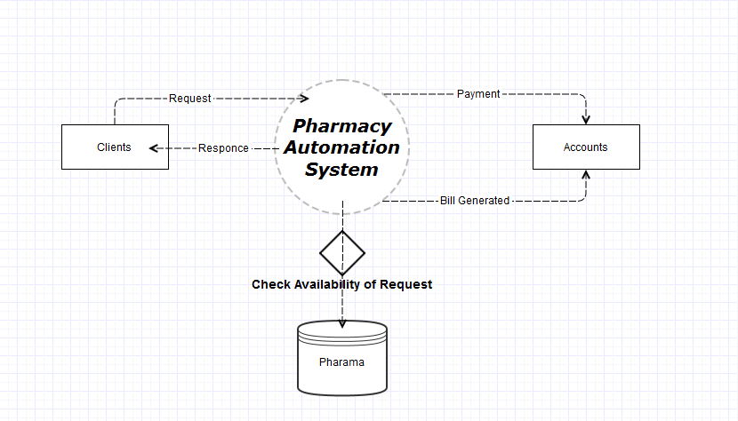

SAMPLE FORMS

SIGN UP FORM

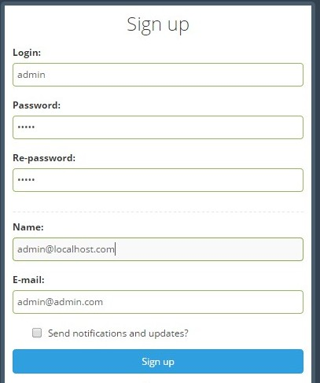

SIGN IN FORM

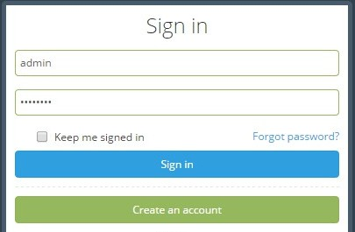

BIBILOGRAPHY

ONLINE REFRENCES:

1. W3SCHOOLS

(<http://www.w3schools.com/php/>)

1. Php.net

(<http://php.net/>)

1. WIKIPEDIA

(<http://en.wikipedia.org/wiki/PHP>)

BOOKS:

1. PHP and MYSQL

4th edition by “W.JASON GILMORE”